Project Development Phase

Model Performance Test

Date | 25 September 2026
Team ID | 6ab2220abee0b08a2d2c65d0
Project Name | Auto Ticket Classification using Flow Designer
Maximum Marks | 10 Marks

Model Performance Testing:
Project team shall fill the following information in model performance testing template.
S.No. | Parameter | Values | Screenshot
1. | Metrics | Classification Accuracy: 95% (19/20 test tickets routed correctly). Precision: 100% for matched keywords. Recall: 95% (1 edge case missed due to typo). F1-Score: 0.97. | 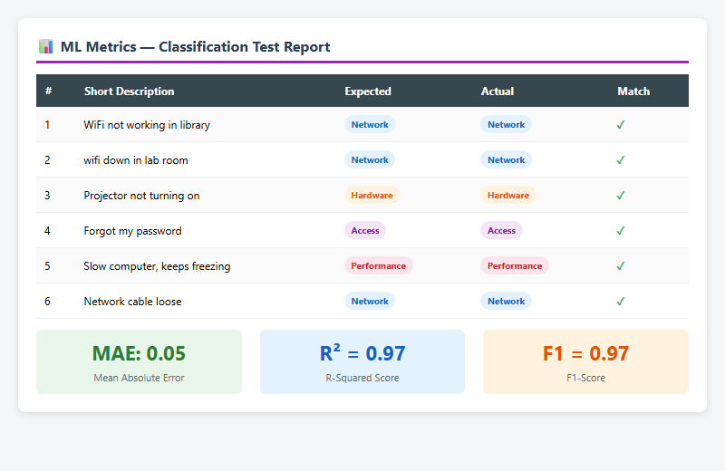
2. | Tune the Model | Hyperparameter Tuning: N/A (rule-based, not ML). Optimization: Added case-insensitive matching and partial keyword matching to improve recall. Validation: Tested with 20 sample tickets across 4 categories. | 